Taurus verses
of the Earth

Street from stairs

On the stairs in the street

Two brothers are smoking weed.

- Yo, man!

Now I feel like our grandfather African.

This weed

Is a true magic indeed.

Big B shared his wide wild smile

With his younger brother Kyle.

Kyle laughed happily,

Kyle laughed loudly.

They laughed together -

Big B and his brother.

- Yo,

You, know…

When there were no cars,

There was less sorrow,

There were fewer tears,

There was no fright of tomorrow.

No cars and no ships

That stole our grandfathers

And took them to these lands,

And tied their hands,

And turn them to slaves.

When there were times

Of sunshine and grass

And thousands of miles

Of the happiness.

And each days tribe songs

Of the Africa sons.

Then all we were free

Like the Sun, like a wind, like a tree.

Big B gazed to space

Remembering those days,

Remembering free times.

Kyle looked at his brother thinking: "Yeh, he is wise".

- Yo, Big B, that stony streets,

That people of the different creeds…

I think that city

Is worth a pity.

Each one,

Even a white man,

Is a slave here.

A slave of the cigarettes, a slave of the beer.

A slave of the system that is always near.

A slave of the crimes,

A slave of the death.

A slave that don’t know his grandfathers’ names.

- Yes,

Many of us

Don’t remember who he or she was.

There remain no people but their sorrows,

Their regrets.

People are making so many mistakes

That they’re turning to shadows,

Turning to robots.

See the man with a tie?

Soon he’ll die

Tired of lie.

He is a barrister.

His client is a gangster.

That gangster’s killing people.

He’s Lucifer’s disciple.

He eats man’s flesh like apple.

Though he is a rich person,

So he’s still not in prison.

He’ll kill his barrister,

If that change the decision

To truly serve his master.

The man with the tie looked around,

As if he's heard some alarm sound.

Then he went on, man…

Knowing he’s helping to kill people with gun,

Knowing that he himself is almost gone.

- Here is the other murder

Not killing by himself.

He’s like a mediator

That sells a slave by slave.

You know that heroin dialer.

- Ye, I know, He is a real killer.

A lot of people bite the dust

Because they trapped to heroin caste.

That who says that heroin’s cool

Is a real fool.

That who’s selling that shit

Soon will Devil meet.

Another half a dead man

Came and bought heroin.

He already feels pain

When there’s no drug in his vein.

Some cold turkey

For a junky.

He’s lost his work.

He’s dump like jerk.

He stole some money

For heroin, that’s sweet for him like honey.

- Here comes an officer.

He isn’t better then a killer.

He's taking tricks

From dialers.

He stinks.

- I know he’s a cocaine fan,

That ugly police man.

He could be very rude

With people like us, dude.

A man like he with no doubt or delay

Can kill children and women because they just don’t want to obey.

Do you remember sixties?

All that poor bitten hippies…

Who just wanted peace?

And all that police daemons,

And daemons-politicians.

- Ye, if you got an authority,

You could kill for it.

Though there is no immortality

For people that behave like a shit.

- If you are like an insect

Or a rat,

You may be eaten by a snake,

Or a bat ,

Or a cat

For the God’s sake

- If you do someone bad,

You may be the second

Prostrated with that

- Ye, I remember Billy,

He was quite silly...

Always dopey

With a poppy.

Once on rainy chilly day

Billy came to man in gray.

He showed a knife and said as usually:

“Give me your money quickly”.

The man took out a gun

And killed the errant African.

- Look! – A girl is buying dope,

Thing and pale just like a rope.

Sad and depressed,

By no one but heroin kissed.

- That sick passion

Can cause death, not only the depression.

They looked with sad eyes

At the girl who’s pale like ice.

Loosing last breath,

Buying her death.

- Do you feel an evil waves?

Here comes

A pimp with girls.

He sells them like slaves.

He eats their souls.

- I can’t bear that anymore!

I am tired of slave-trade store

That I see in all our streets!

I see that our country bleeds!

I want to go to the land of our grandfathers!

Let us go to Africa you and me – two brothers?

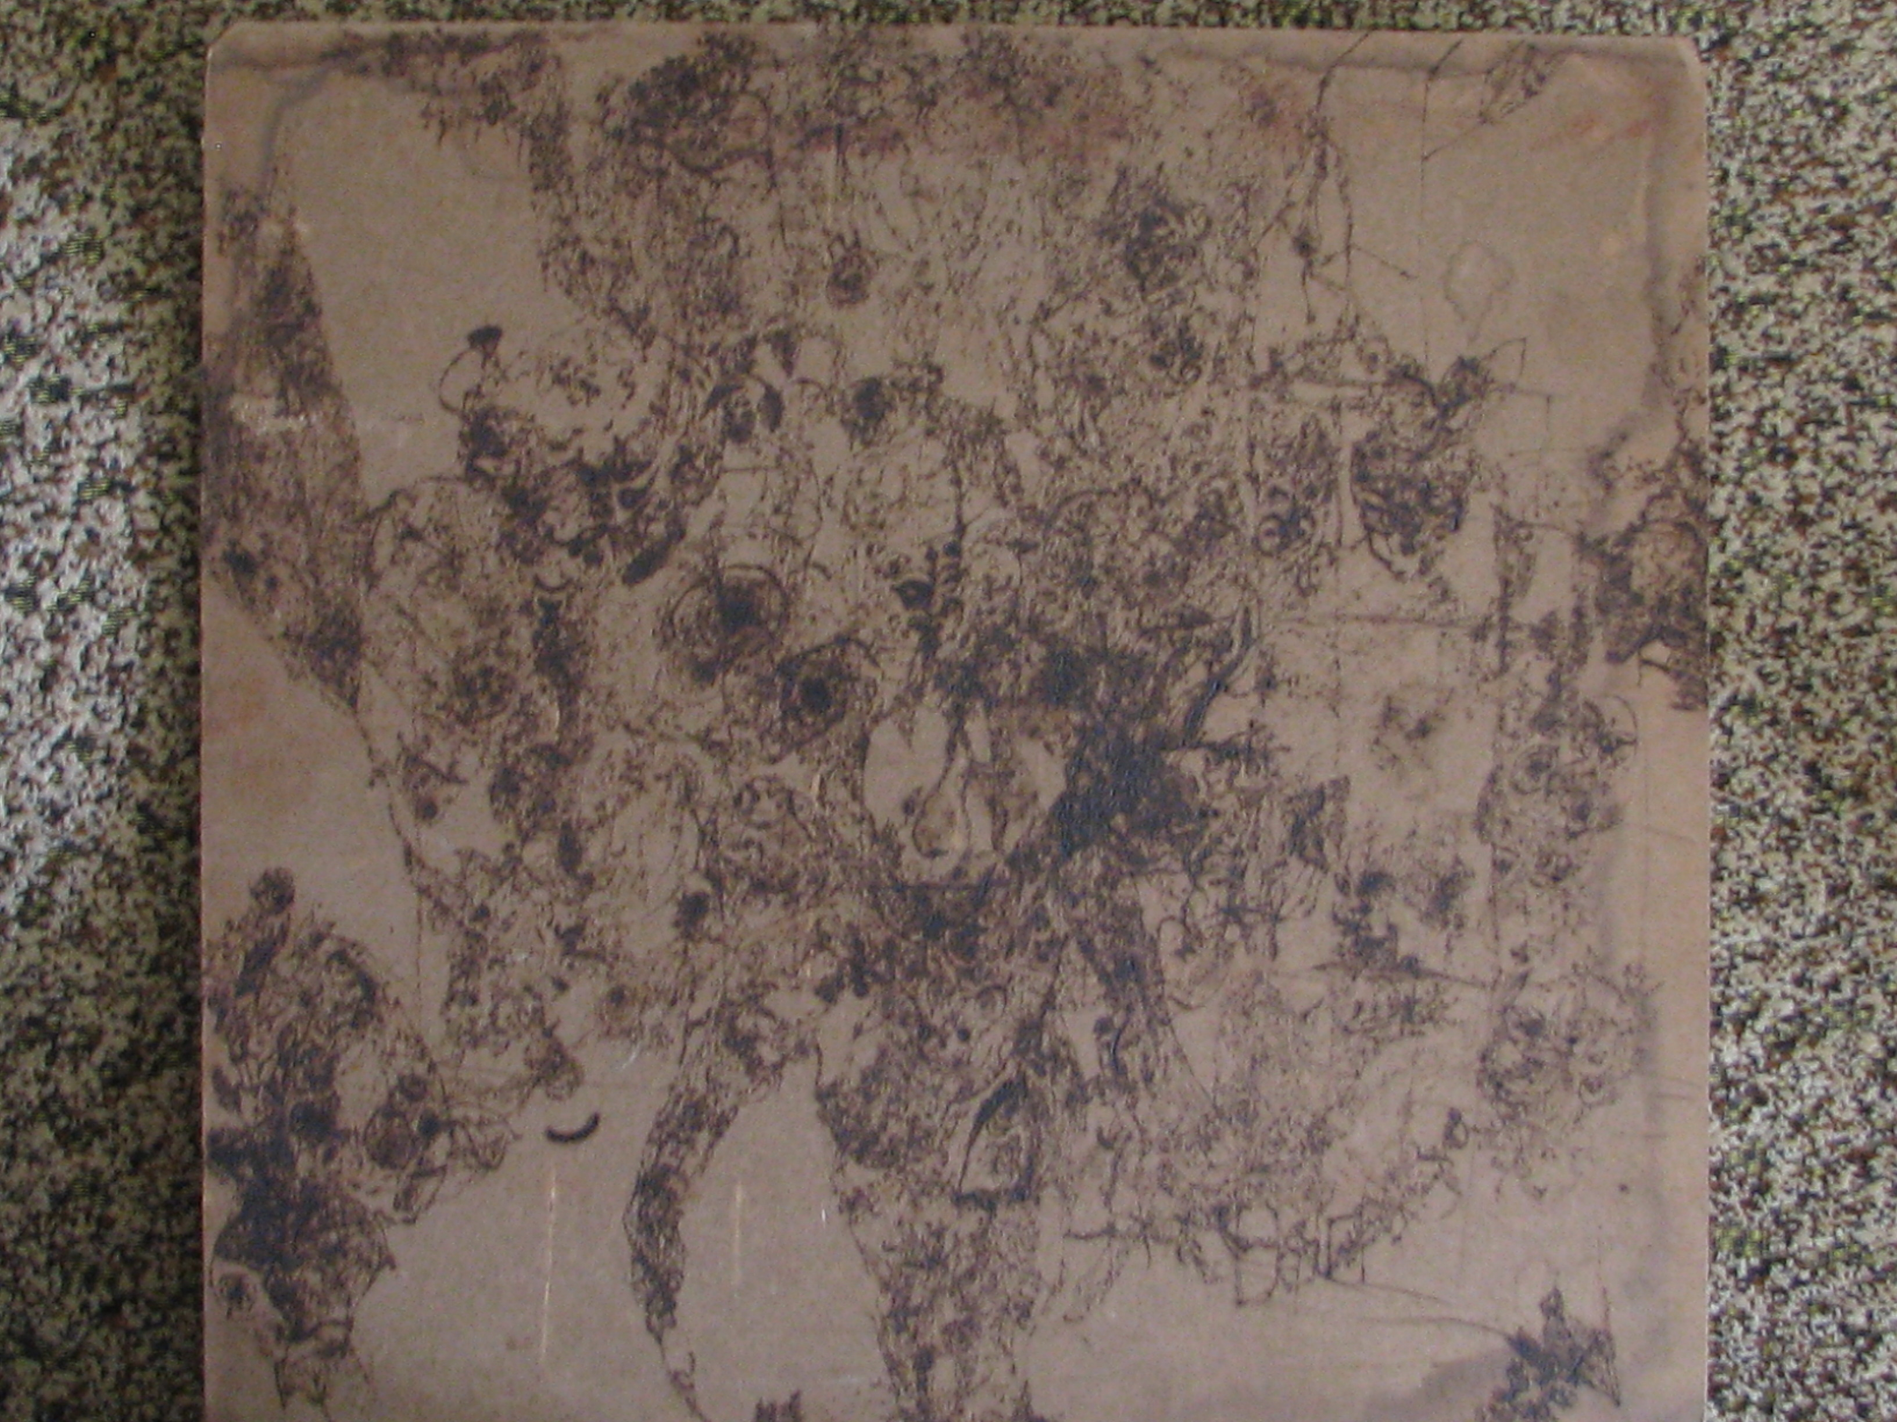

7

There’re seven inside me

I suppose

While they're behind the walls

They howl

That's made me nervous

Thus

Seven brakes

In the stairs

Seven snakes that could bite

Seven fears

Seven lies

Seven steps

To the death

Seven guards of the prison

In which I abide

And in the same time

They are five senses

Life and death

The seven colors

Of the rainbow

And seven planets

Which exist behind the ours

II

I’m far away from home

Alone and frightened in a field

And aching of each bone

Is just like trifle…

Mere bagatelle,

Like an abrasion for a child

But what about wild hunger

Of the soul

The hunger of the wolf

Vampire’s hunger

Piercing chill and darkness

There’s a body

Torn to tatters

It doesn’t matter

It is mine

But hunger’s still inside

A need for something

That is

So loved

And intimate

But lost in whirlwind

Of the passions

That’s filtered out

By conscious of homeliness

That’s lost in stream of cars

And barking of the dogs

That is deleted by a hand

Of man with a pale face

And thin grey lips

It seems to me that it is close

At finger’s end

And still it can’t be found

Nevertheless I won’t give up

There’s no epitaph, no grave

But I could feel that I’m dead

I’m just a shadow

Piece of darkness

Piece of send

A part of chill that is eternal

But what is that?

A hand on shoulder

And whisper in the ear

“I know you well

And all your fears

And all your needs

Beliefs and sorrows

And regrets

Since now I couldn’t disappear

It is my will

And yours

Of cause

Was me to come

Since now you’re not the man you were

Since now I’m you

And vice versa”

I turned my gaze away of corpse

Away of that dead man

Whom I had eaten

Away of that one breathless body

That once was mine

I turned to that who’d came

And saw the flame

And entered it

And turned to it

And then came out

Out of Sansara that’s revolving

Rolling on and on non-stopping

Which each new turn makes some new sound

What else to say – I was astound

Short Sci-Fi Thriller Verse

What
A cruel world
Humans’ minds are caught
In the cyber net
To create
Artificial intellect

As powerful as all human beings together
The program is going to gather
All the possible knowledge
And it comes to the edge

It sees
All possibilities
And it uses utilities
To develop creatures
Which serve it for centuries
Collecting people’s
Passions and memories
To fulfill itself
With a natural existent

The cyber net uses bio power
Like junks use cocaine powder

Democracy

See a bum at the corner?

He's asking for a cent or a dollar.

Last winter he lost his fingers on feet.

Now he’s cold again and has nothing to eat.

He was a navy captain.

Now he’s a poor man.

It seems like democracy

Is being crazy.

He served his government truly.

The government fooled him fully.

What sense in the country

That leaves its citizens hungry?

Remember Bob Marly’s “Rat race”?

Oh, he saw a real democracy’s face.

Once half of the Europe died of rats,

Rats were the reason of so called Black Death.

For you to better understand my words

Let me compare the government board with pirate death boards.

The further you go – the nearer the death.

And politicians like sharks -

Are ready to take your last breath.

At first they were killing Indians.

Now they are sending soldiers

To oppress other humans,

For example, the Afghans.

Remember USSR?

There was a republic Ukraine.

There leaved 52 millions people.

Now it’s something like forty seven.

Five millions are gone

Killed with neither bomb nor gun.

They were eaten by a rat

The name of which is government.

You know most everyone

In the Soviet Ukraine

Had a great deposit account

All the money were stolen when USSR failed

And people left astound.

Is it a democracy that makes people proud?

Nature’s splendor

Strolling in the street you may see

Busy people walking fast

Busy people driving cars

And at last –

A tree.

It stays beyond human appetites.

It doesn’t know passions of any kinds.

It sings with wind in unison.

The tree and the world is one union.

And people are running

Don’t noticing

That it is amazing.

Look at its bark -

It isn’t dark.

It’s like a masterpiece.

It’s like the best world’s pictures.

Look at the leaves -

You know, they’re like the God’s kiss

Make the air clean, allow people breathe.

Look at the branches basketry -

It is full of mystery

Full of hieroglyphs, magic signs.

So, why are we, the nature’s daughters, sons

Overpass

Don’t noticing heaven’s door –

Nature’s splendor?

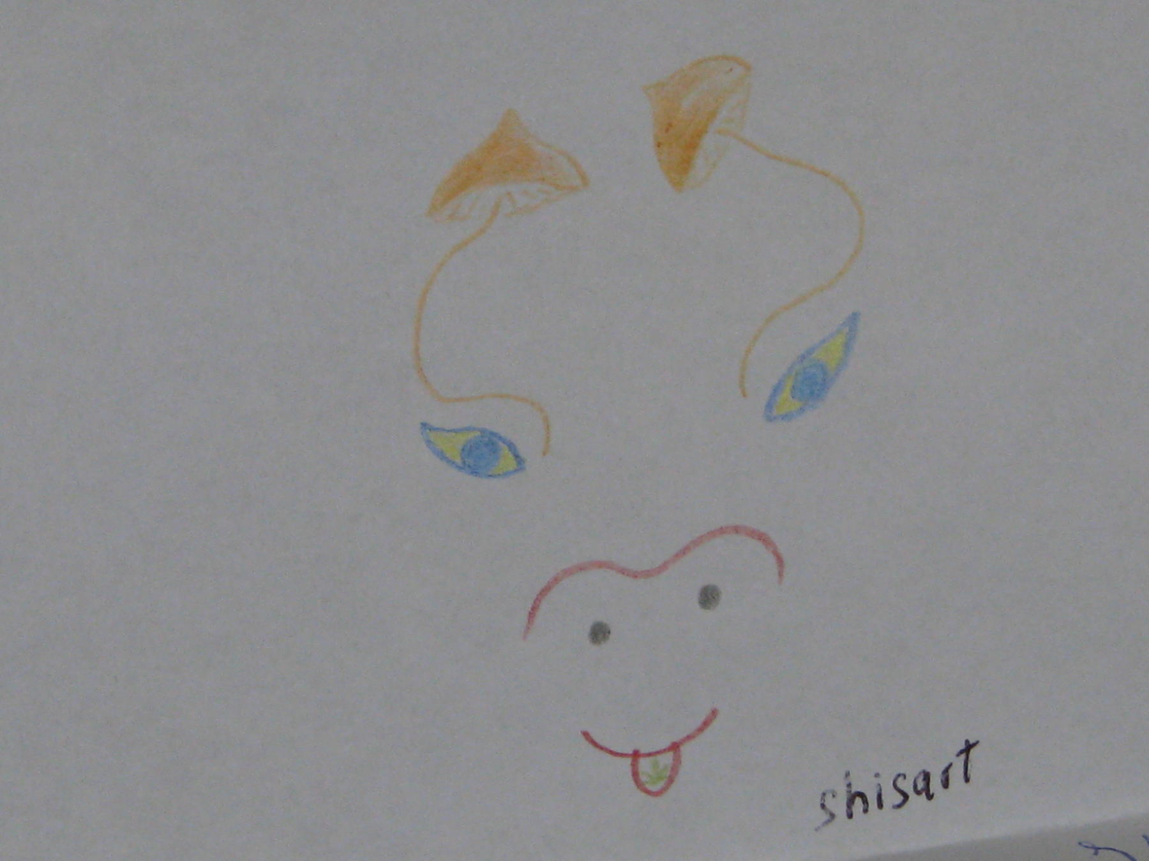

The Heart

The heart knows where to go,

And on its way it could break a wall.

The heart knows how to fly.

It hates a lie,

It loves to laugh and cry.

It could remember why

One breath and die,

And does some crazy things.

It may allow one feel the kisses

Of the sky.

Crow and me

A crow was sitting on a tree.
It said to me:
"Do take my eyes".
Repeated twice,
I didn't hear.
I even didn't mention it
And didn't recognize.

It flew from tree onto my head
And pecked me in my nose.
I turned to red
(Just like a rose)
And shouted at that bird.

It listened placid as the ice
And then repeated: "Take my eyes!
Remember you, you were a child,
We played together and had fun...
But whom I knew, now he is gone.
You're silly, blind and deaf.
So take my eyes! You’ll see yourself!
You'll see all things...
And who you were, and whom could be,
And maybe then you'll take my wings
And fly onto the tree.

How I was bumped by a train (real story)

You know, lots of times
I’ve been faced with unjustness.
There are cops, who are to protect our rights,
Though they are as evil as dragons.
Authority is the worst of things.
It makes human beings
Dangerous.
(Yes, I’m talking about cops)
Oh, it seems
For them so precious,
So precious
Blood drops.
And their mad ugly faces
Are telling that human not worth
Existence.

Once traveling by the train I have missed my station.
And met the police demon
It made the solution
That I’m a junk person
(I just wanted to stay with my fallow-traveler
To stay with someone who’s dear to me for some longer).
They’ve beaten each inch of me
They’ve made me half-conscious
And live in the night on the rails
Without any money and with bruise on the face.

I was walking
Didn’t knowing
Where am I
Turning bruise to the sky.
Stockstill state of my brain
Didn’t care of warning signal of the train.

So, that night
After the fight
I was so lowered that had a flight
Within the loco’s sound.
At Lockie’s side
At Jesus’ sight
I was by the train bumped.

I was rent from the earth.
Then I hit the train with shoulder.
I fucked that train in hundred words.
Staying at the death border.

I was lucky to got only a broken arm,
Though it could be more serious harm.
So why those who are to protect our rights
Cripple our bones and spoil our minds?

Broken flowers of our hopes

Broken flowers
Of our hopes
Regrets and sorrows
And tears in eyes
How many times
It comes to this
How many times God dies

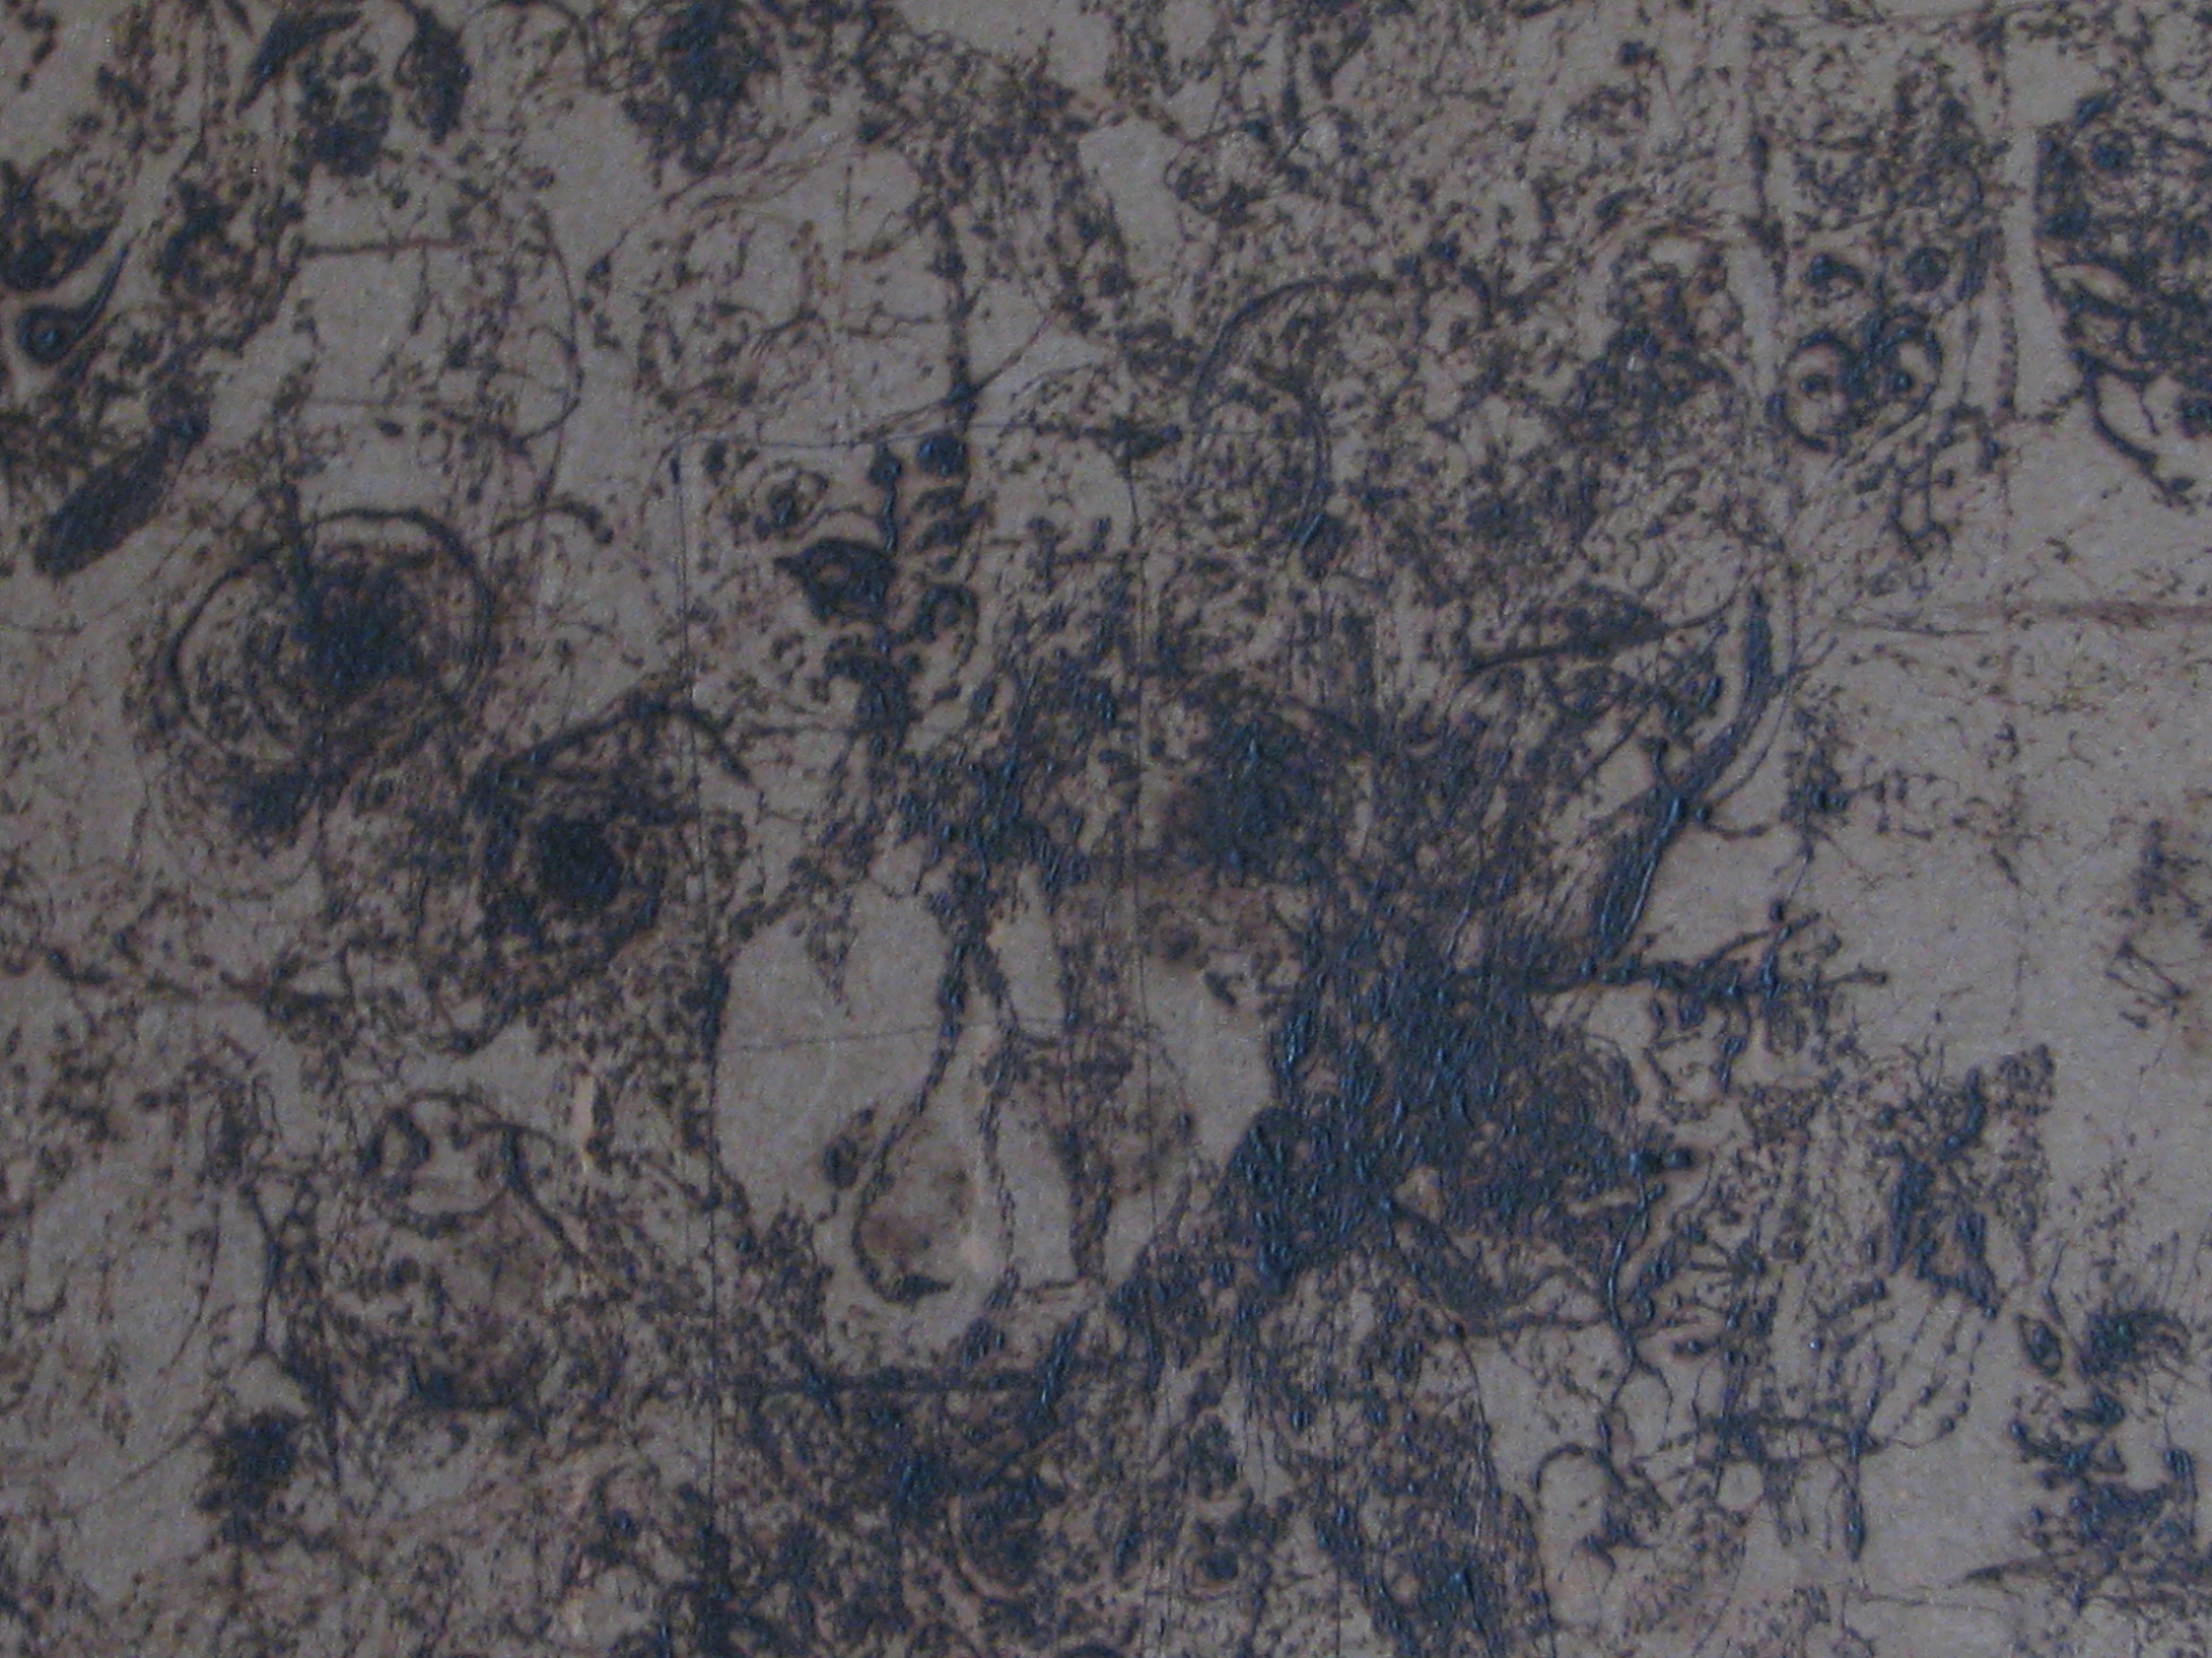

Autumn

Fires on both sides of the road

Narrowing space between dome and bottom

Hear a crow says: “Autumn!”

Old elm is talking with a wind

Dead man is signing blues

Autumn spreads her wings

A comet in the sky appeared

The river's water's frozen into ice

It is a birth of a new universe

Shamanism

The wind is playing with flame and smoke.

We're near the river. Our existence is a song.

We're dancing. All the clocks broke.

River flows with a song of monk.

When the sun makes the air

Crayon

While rising,

The river is moaning

Like a whale.

The river sings with winds

And our hearts.

It sings with leafs on trees.

It sings with bushes and with birds,

And butterflies, and bees.

Hip-hop is dead music

Do you think
No sin
Will make you sink
And you sing
About your golden chain and ring
Do you think
It’s no use in saying: “Thank”
And you found benzine
To your chasmal tank
And your eyes are smiling assured and dry
When the children of the Africa cry

Don’t say me anything
You have changed your soul to a stony thing
You have forgotten about your roots
You are like a rat, you are like a louse

There’s no use
To lose
There’s no sense to win
When the only goal
Is to feed your sin
When you stuck your soul
In the money world
When you’ve built a wall
Over all

Don’t say me anything
You have changed your soul to a stony thing
You have forgotten about your roots
You are like a rat, you are like a louse

Restless

I don’t know why we’re so restless
We stroll through the all ways
With our awareness
And we find our selves bottomless
Day by day passes
We pass through the masses
Blacks, whites, who cares?
All that color mess
Means nothing
The only thing
Is you and your dream
And not the color of the skin
Be yourself, be everything
The whole world is within
You dude
Feel your root
And all be good
All of us
Are people of the Earth
Earth is the only pass
To the skies

I don’t know why we’re so restless
In our attempts
To be not useless
To feel the Universe
To develop my mind
I find
A lot of the ways
Snakes bite
With no delay
Those who stay idly by
Gazing at the idols
And losing own minds
And turning to dolls
Shame on those
You should act
With your body and your intellect
You should grow tall like a tree
To be free
Rule for all boys and girls
Who want freedom to find
“Roots in the Earth
Stem stretches to the sky”

